Positive Behaviour Policy

December 2023

Version | Date | Nature of change | Reason | Author(s) | Ratification at FGB date
1.0 | December 2023 | New policy to replace old version | Response to Ofsted | AH

Contents

The Harrowbarrow approach to behaviour: The Harrowbarrow Way | 3
Roles and responsibilities | 4
Strategies for promoting positive behaviour at Harrowbarrow | 5
Limit setting, consequences and sanctions – KS1 and KS2 | 8
Suspensions and exclusions | 9
The use of reasonable force | 10
Behaviour around the school | 11
Early Years and Foundation Stage | 11
Child support | 12
Safeguarding | 12
Child transition | 12
Child conduct outside the school gates | 12
Record keeping and data analysis | 16
Induction and training | 16
The application of this policy | 16
Appendices | 17

The Harrowbarrow approach to behaviour

Our school values are at the heart of all we do at Harrowbarrow, and we aim for all children to learn to embody our values: Respect, Kindness, Resilience, Ambition, Equality and Truth. We want our students to develop into responsible citizens, upholding British values, playing an active part in the school, local and wider communities. At Harrowbarrow we educate children around statutory protected characteristics and we do not tolerate bullying of any form. We believe that all members of the school community deserve to be consistently treated with dignity. We recognise that our primary school encompasses a range of developmental stages and ages and application of this policy is considered through these.

Through our curriculum, and our focus on child wellbeing, children have the opportunity to value each other and explore and articulate their feelings. Through developing self-awareness and motivation, children will be well-equipped for their futures.

We acknowledge that behaviour is communication and it may be communicating a number of things including a communication, sensory or social, emotional and/or mental health (SEMH) need. Therefore we use methods such as emotion coaching and restorative conversations to teach children how to manage their own behaviour, in a way that will be supportive to their future.

We have high expectations of behaviour and high expectations of all staff to ensure that the right support is in place to enable children to thrive. At Harrowbarrow Primary School all responses from adults to the behaviour of children are informed by the principle of considering what the child is learning from the adult’s response, and how that response will support the child with their future behaviour; this is based on our whole school compassionate ethos and a research informed approach. A foundation of our school is that all staff understand the importance of positive relationships between staff and children. Furthermore, children are encouraged to choose a ‘trusted adult’ who they can go to if they ever have any concerns.

We work in collaboration with parents and welcome questions and conversations about our approach to behaviour at Harrowbarrow. All staff across the school including lunch/playtime support staff follow this policy and are trained in our whole school strategies.

The Harrowbarrow Way

So everyone at Harrowbarrow can be aspirational, adventurous, individual, enlightened and compassionate we need to behave in certain ways; we need to be “Ready, Respectful and Safe”. (Dix, P. 2017). These are our school rules and this is The Harrowbarrow Way.

Our children and teachers have used our school rules to co-create our behaviour principles (these are outlined below – we have four principles per rule). These in turn have informed our whole school behaviour curriculum (see Appendix 1: Behaviour Curriculum – The Harrowbarrow Way) which includes a “What Makes Good” for each behaviour principle. These behaviour principles are explicitly taught and are consistently referred to throughout the year to re-establish expectations by all across the school to ensure these rules are embedded and sustained. In line with our whole school approach to behaviour and our inclusive ethos, we understand that some children require more support to meet this expectation.

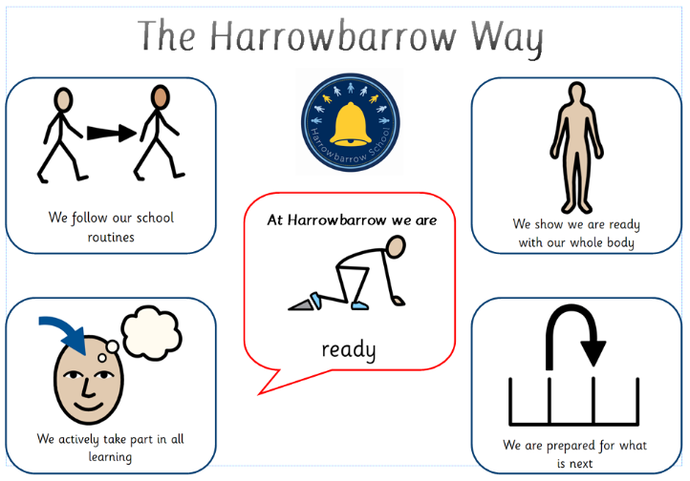
“At Harrowbarrow we are READY”

At Harrowbarrow we encourage children to take ownership of their learning and show readiness to learn by being present, positive and engaged.

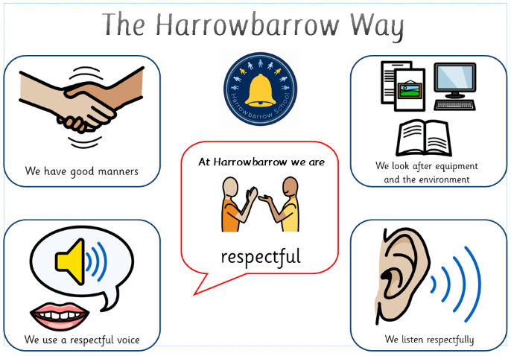
“At Harrowbarrow we are RESPECTFUL”

Relationships and attitudes at Harrowbarrow are built on mutual respect. This respect extends to ourselves, one another, our equipment and our school environment.

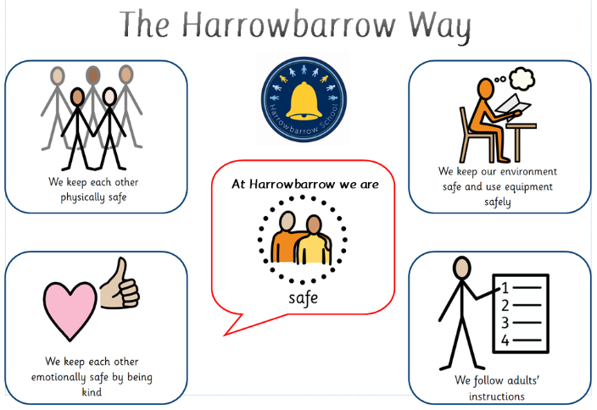
“At Harrowbarrow we are SAFE”

It is essential that everyone in our school community feels safe at school and that we conduct ourselves in a way that ensures the safety of everyone. This includes emotional and physical safety.

Roles and responsibilities

The Harrowbarrow School Governing Board is responsible for ratifying this policy and monitoring its effectiveness and holding the headteacher to account for its implementation.

The Headteacher is responsible for reviewing and approving this policy.

They will ensure that the school environment encourages positive behaviour and that staff deal effectively with negative behaviour, and will monitor how staff implement this policy to ensure rewards and sanctions are applied consistently.

In addition to this they are responsible for:
- Putting in place sanctions and consequences for bullying and oppressive incidents.
- Meeting with children, staff and parents regarding serious behaviour incidents.
- Suspensions and exclusions.
- Addressing day to day incidents of behaviour as a member of the Leadership Team.

The Senior Leadership Team is responsible for:
- Establishing positive behaviour and culture for each key stage in line with school behaviour policy
- Analysing behaviour logs (MyConcern/Reflection Sheets) for trends and ensure all are actioned and closed weekly
- Following Tier system
- Leading/Facilitating TAC meetings for individual behaviour plans

- Leading team reflective practice meetings
- Be the first line of support for teachers in thinking through individual behaviour challenges and developing classroom behaviour strategies
- Supporting teachers when meeting parents regarding behaviour
- Arranging and attending TAC meetings to develop individual behaviour plans
- Following responsibilities as outlined in the tiered system.

The SENCO is responsible for:
- SEND behaviour.
- Observing and/or discussing more concerning continued behaviour following Senior Leader intervention.
- Involvement in TAC meetings – both internal and external.
- Putting in place support for children with additional needs in class or/and the playground at challenging points in the day.

The Emotional Health & Wellbeing Support Worker is responsible for:
- Being proactive in promoting regulation as day to day flexible support.
- Being the emotionally available adult for specific children at key points in the day.
- Involvement in TAC meetings – both internal and external.
- Maintaining awareness of impact of trauma on behaviour.
- Support and preventative measures for negative behaviour through targeted intervention.

Staff are responsible for:
- Implementing the policy consistently.
- Delivering the behaviour curriculum so that all children know, understand and are able to follow the rules of Ready, Respectful and Safe.
- Modelling positive behaviour.
- Providing a personalised approach to the specific behavioural needs of particular children.
- Recording behaviour incidents on MyConcern.
- The senior leadership team will support staff in responding to behaviour incidents.

Parents are expected to:
- Support their child in following the school rules of Ready, Respectful and Safe
- Inform the school of any changes in circumstances that may affect their child’s behaviour.
- Discuss any behavioural concerns with the class teacher promptly.

Children are expected to know, understand and follow the rules of Ready, Respectful and Safe. Strategies for promoting positive behaviour at Harrowbarrow

Positive Relationships

Relationships at Harrowbarrow are given central importance: positive relationships are established, maintained and restored where needed, using evidence based strategies (EEF, 2019).
Behaviour is understood to be communication and adults reflect on what a child is communicating with their behaviour if this is unclear. Adults consistently remain calm when responding to children’s behaviour.

Classroom Management Strategies

At Harrowbarrow we focus on and praise positive behaviour. We have whole school classroom routines and high expectations for behaviour of all children (see Appendix 2a: Systems which support behaviour within the classroom). We have reward systems in place (see Appendix 2b: Reward Systems) and place emphasis on praising effort and demonstration of the school values, as well as academic achievement from the child’s starting point.

Children understand adult expectations of them and are clear on what is expected. Clarity and consistency are understood by all staff to be crucial to positive behaviour management.

Teachers/support staff are supported by Senior Leaders to ensure that classroom behaviour management is consistent and positive in their classrooms.

Rewards and positive praise

Our aim is to develop children’s intrinsic motivation and growth mindset, the belief that our success can be developed over time as we grow, make mistakes and learn. We acknowledge that extrinsic motivators help children establish positive behaviours, and develop intrinsic motivation, we use these alongside specific praise.

At Harrowbarrow, children are given specific praise for both their effort and achievements from their starting points. In addition to this verbal praise, children across the school are awarded certificates that recognise the contribution they have made in adhering to the school rules of Ready, Respectful and Safe. Below are some examples of when these would be awarded:

- Following routines and engaging fully in all tasks
- Effort and participation in lessons; being an active learner
- Demonstrating readiness
- Outstanding manners
- Following instructions
- Looking after the school environment to keep equipment and those using it safe
- Showing kindness that keeps others emotionally safe

All staff working with children can nominate them for a weekly award.

In addition, classes can work together to gain praise/team points. Each class will have their own goal. When goals are achieved a class award is secured. These awards may include extra play, a games sessions, a special activity or a reward agreed with the class teacher. Class praise/team points can be awarded by all staff working with the children. Points are awarded when the class demonstrate adherence to the school rules e.g. the children tidy up the classroom promptly at the end of the lesson.

Headteacher awards are given to children who have produced outstanding learning outcomes from their individual starting point. Adults working with those children decide when they deserve special recognition for their efforts. The headteacher will look through their learning with them and award them a special praise sticker.

Year 6 Learning Ambassadors play are important role models in demonstrating the Harrowbarrow Way. They support younger children in their learning, their play and routines such as lining up and moving about the school. In recognition of the contribution they make, they will be invited to afternoon tea with the headteacher once a term.

Celebration Assemblies are held weekly. During these, teachers award certificates to children who have best demonstrated their adherence to the rules and our school values in a variety of ways. Children are invited to the front of the assembly, class by class, where their teacher acknowledges their achievements. Other extra-curricular achievements e.g. sporting / musical awards/reading challenge are also celebrated. If children wish to share extra-curricular achievements from outside of school, these are celebrated through the fortnightly newsletter.

Restorative Conversations

At Harrowbarrow, we believe children respond best to behaviour intervention when it is done in collaboration with them and they are encouraged to take responsibility for their actions. Having high expectations of pupils, setting clear boundaries, fostering a high level of discipline whilst supporting children through encouragement and nurture will help ensure a restorative approach.
Restorative conversations help children to reflect on their behaviour, the impact it has had on themselves and others, how they can make amends for their actions and what they might do differently if faced with the same situation again.

Adult dos and don’ts for promoting positive behaviour for learning

- Adults in the school will not shout- nothing is gained by being verbally aggressive or modelling a lack of control – reactions to negative behaviour should be non-emotional, limiting attention on the child, given in private where possible (i.e. not in full view of the class) and delivering a consequence if needed. After a lesson has finished, take time to explain your decision and give the child a chance to ‘fix’ the situation if appropriate (in addition to a consequence).

- Adults in the school will not use overly emotional words to describe behaviour (children’s behaviour is never ‘disgusting’ or ‘terrible’). They will be specific about describing behaviour.

- Adults in the school will not ask questions that tempt inappropriate answers, for example, ‘Would you do that at home?’ ‘Where should you be?’ and ‘Would you like it if that happened to you?’

- We describe the behaviour and the impact and the impact on the child and others: “You called x … and that made x feel very angry/upset. We don’t call people names at Harrowbarrow. You will need to miss some of your play whilst….’

- If an adult makes a mistake or jumps to an incorrect conclusion – they will apologise. It is important to model mistakes are normal and that we take responsibility for our actions.

- Adults will focus on redirecting behaviour back to learning rather than focusing on inappropriate behaviour.

- The tone of voice and the way the adult structures redirection so that it is aimed at the behaviour, not the child, is essential. Polite, calm language structures must be used at all times. A harsh, strident aggressive tone is counter-productive and produces a negative, aggressive response in the child’s brain.

- Adults will use ‘we’ when talking about expectations: ‘At Harrowbarrow, we keep each other safe so we do not throw pencils’.

- Adults will use ‘if’ and ‘then’ to clarify actions and consequences, e.g: ‘If you continue to be unsafe and throw a pencil, you will then miss your play.’

- Adults will follow through on ‘if’ and ‘then’ statements made but do not make threats which do not follow the school system and this includes giving class or group sanctions where an individual or individuals are at fault.

- Adults will ensure they arrive to collect their class from the playground at 8.55am (start of the day), 10.55am (morning break) or 12.55pm (lunch time) – arriving afterwards leads to unattended lines of children.

Limit setting, consequences and sanctions - KS1 and KS2

At Harrowbarrow we believe in public praise and private reprimands or sanctions. This ensures children are treated with dignity and respect.

Our expectation is that all children follow the rules of Ready, Respectful and Safe. These rules are explicitly taught through whole school assemblies and in class. They are referred back to throughout the year to re- establish expectations. In line with our whole school approach to behaviour and our inclusive ethos, we understand that some children require more support to meet this expectation.

Staff use a number of behavior management tools to support children in making the right choices or de-escalate a situation. Some examples of these are:
- Verbal advice and support
- Choices/consequences
- Using diversion & diffusion e.g. engaging the child in a discussion about a favoured topic
- Using negotiation
- Proximity praise
- Praise for doing the right thing previously
- Following set school scripts
- Non –verbal cues such as looks and touch
- Time out and movement breaks offered
- Re-assurance
- Planned ignoring
- Redirection to another activity
- Humour (but never sarcasm)

If these strategies do not work, adults will use the warning system by going through the following steps (See Appendix 3a: Step Chart):

Step one – Reminder of the expected behaviour e.g.: “This is a reminder that at Harrowbarrow we are Ready/Respectful/Safe so we face the front and listen. Thank you.”

Step Two – Verbal warning. “I’ve reminded you to be Ready/Respectful/Safe so we face the front and listen. This is now a warning that unless you do so, you will miss some of your play.”

Step Three – The child will be informed that they are missing 5 minutes of their play as a consequence (this is proportionate as outlined in sanctions). This must be followed through – if you are on duty please ask a partner teacher to have the child. This consequence then marks a ‘clean slate’.
A timely restorative conversation needs to be had at an appropriate time. Record the incident on MyConcern including the action so patterns can be monitored. Reflection sheet may be used (See Appendix 3b: Reflection Sheet).

If multiple times in a short space of time for example a week, a discreet verbal conversation home is needed.

Step Four – If the low level disruption continues and it’s disrupting the learning of others, the child will be sent to work in another class (See Appendix 3c: Receiving a child into class and back into class). The child will take their learning with them. If the child refuses to leave the classroom or this is not deemed a sensible action, a member of the senior leadership team will be contacted to assist (Step 5).
- This is time to calm, no blame or judgement is needed, this is a process. It allows the child to move on and return after no more than 15 minutes.

Step Five – Go to Senior Leader. If this is resisted send a request for SLT to come and collect them.

The Warning system is cumulative but it should begin again for each new incident. Warnings should not be held over children for longer than one teaching session.

Sending for assistance

  - Send a child or telephone the office/staffroom/HT’s office to request assistance when a child has not responded to reminders / warnings, is being persistently disruptive or has engaged in the serious misbehaviour outlined above.
  - A member of SLT / will attend to support the teacher/adult in charge.

Some behaviour is of sufficient seriousness that it will be dealt with by a senior leader and no warnings will be given. These behaviours may include:
- Bullying/racism/homophobic language
- Swearing or obscene language
- Fighting or intention to harm
- Vandalism (school property or that of other children)/stealing
- throwing objects that endangers others
- Serious challenge to authority of any member of staff/arguing with a member of staff/verbal abuse to staff
See ‘Appendix 3d: Behaviour and sanctions chart’ for further guidance.

If a child is repetitively struggling with their behaviour, and this is impacting on their or others learning or safety, this will be recorded on MyConcern so that senior school staff can look for patterns, share this information with parents and other staff and co-create a personalised behaviour plan through a ‘Team around the Child’ meeting.

Suspensions and exclusions

The Headteachers have the right to suspend (internal, external, fixed term or permanently exclude) a child. This will always be proportionate, only in extreme circumstances and in line with statutory guidance and Tier 3 behaviour outlined in Appendix 3d.

The Headteacher may suspend a child for one or more fixed periods which do not exceed a total of 45 school days in any one school year. During a suspension of 5 or fewer days, work will be set by the class teacher for the child to complete at home. This work should be returned completed at the end of the suspension for marking. During the first five days of any suspension, the parents/carers of a suspended child must ensure that their child is not present in a public place during normal school hours without reasonable justification, whether with or without a parent/carer.

Suspensions which result in the student being suspended for more than 5 school days must be reported to the child’s local authority. The school must arrange full-time educational provision from the sixth day of suspension (this should be provided by the local authority in cases of permanent exclusion). Any suspension which may result in a student missing a public examination must be reported to the Governors and to local authority.

Procedure
  - A senior member of staff will phone home to inform the parent or guardian of the decision to suspend and arrangements to follow.
  - Work will be sent home for the child to complete and then return.
  - A suspension letter will be emailed to the parents from the Headteacher. The letter will include the following: length of the suspension, reason for it, date for return, support moving forward and invitation to a reintegration meeting.
  - The suspension will be logged on SIMS and details of the incident will be recorded on MyConcern

Reintegration meetings

Upon return there must be a reintegration meeting to ensure the child has a successful reintegration back to school. The meeting will help the child understand the impact of their behaviour, resets expectations of the school behaviour, renews sense of belonging and gives the child a fresh start. Behaviour targets will be set to be reviewed after two weeks of reintegration.

Suspension thresholds

Number | Thresholds | Steps to consider
Suspension 1 | Reintegration with the Assistant Head for Phase or Inclusion | Educational Psychologist referral, pastoral referral, family support with the family liaison officer, SENCO observation, review and adjustment of provision, moving class, EHCP application, CAMHS referral,  adjustment of provision, referral to school’s therapeutic offer Unlocking Potential, reduced timetable in line with  DfE guidance, Referral to OH
Suspension 2 | Reintegration with the Assistant Head for Phase or  Inclusion | As above and/or:  Internal team around the child meeting and resulting actions
Suspension 3 | Reintegration with the Headteacher | As above
Suspension 4 | Reintegration with the Headteacher | As above and/or:  Referral to Family Early Help, placement to an  alternative provision considered, external team around the child professionals meeting with parents
Suspension 5 | Governors warning to be organised (risk of permanent exclusion if suspended again before the governor’s  warning) | As above
Suspension 6+ | If a child receives 6 suspensions in a year, the Headteacher will consider permanent exclusion for persistent breaches of  the behaviour policy | Referral to the local authority to arrange suitable full time education elsewhere
The local authority is notified of all suspensions through Family Early Help Permanent exclusion
The decision to permanently exclude a child is a serious one and is for the Headteacher to take. The decision to permanently exclude should only be taken:
  - In response to a serious breach, or persistent breaches, of the school’s behaviour policy; and
  - Where allowing the pupil to remain in school would seriously harm the education and safety of others in the school.
Permanent exclusion is usually a last resort and other options to avoid permanent exclusion will often be considered such as alternate provision or a managed move.

The use of reasonable force

What is reasonable force?
- The term ‘reasonable force’ covers the broad range of actions used by most teachers at some point in their career that involve a degree of physical contact with children.
- ‘Reasonable in the circumstances’ means using no more force than is needed.
- Control means either passive physical contact, such as standing between children or blocking a child's path, or active physical contact such as leading a child by the arm out of a classroom.

- Restraint means to hold back physically or to bring a child under control. It is typically used in more extreme circumstances, for example when two children are fighting and refuse to separate without physical intervention.
- School staff should always try to avoid acting in a way that might cause injury, but in extreme cases it may not always be possible to avoid injuring the child.

Who can use reasonable force?
- All members of school staff have a legal power to use reasonable force.
- This power applies to any member of staff at the school. It can also apply to people whom the headteacher has temporarily put in charge of children such as unpaid volunteers or parents accompanying students on a school organised visit.

When can reasonable force be used?
- The use of reasonable force is an absolute last resort. If a child is at risk of hurting another child, then we ask the other child to remove themselves from the situation so they can’t get hurt. The staff then talks to the child who is angry to calm them. Staff are asked to use every means possible to de- escalate a situation before having to resort to restraint. However, the safety of the child, other children and adults are the number one priority.
- Dependent on need, key members of staff may be required to undertake restraint training (Team Teach) and can then be called upon in the event of a child needing to be restrained. However, this may not be feasible in all situations.

In the unlikely event of a serious breach of behaviour the school can use reasonable force:
- When behaviour disrupts the learning of others and the child has refused to leave the classroom;
- To prevent a child from attacking a member of staff or another child, or to stop a fight in the playground
- When a child is at risk of harming themselves through physical outbursts.
- The school will record all attempts to restrain a child in a Restraint Log which will be by the headteacher. If the school has restrained a child, then the parent will be informed.

The school cannot use force as a punishment – it is always unlawful to use force as a punishment.

Behaviour around the school

See Appendix 4a: Expectations for moving around school and Appendix 4b: Lunchtime Behaviour. Early Years and Foundation Stage
For our youngest children, they are at the developmental stage where they are learning how to behave
appropriately. Our approach to behaviour is rooted in our Early Years Curriculum; we recognise the uniqueness of each child and their developmental needs. Our learning environment is a safe place which nurtures self- respect, growing self-esteem, empathy for others and the ability to guide behaviour through learning social skills such as negotiation and problem solving.

At Harrowbarrow we are proud of the strong relationships modelled in the Reception setting. Adults know children exceptionally well and these relationships support positive behaviour. The school values and being Ready, Respectful and Safe underpin practice here as with the rest of the school.

See Appendix 5: Early Years and Foundation Stage for further guidance.

Child support

Harrowbarrow recognises its legal duty under the Equality Act 2010 to prevent children with a protected characteristic from being at a disadvantage. Consequently, our approach to challenging behaviour may be differentiated to cater to the needs of the child.

The school’s special educational needs co-ordinator (SENCO) will evaluate a child who exhibits challenging behaviour to determine whether they have any underlying emotional needs that are not currently being met. Harrowbarrow has an Emotional Health & Wellbeing Support Worker, who has a wealth of expertise with regards to behaviour and to support individuals and groups. They focus on enabling children to make links between their feelings and behaviours in order to support them in making alternative choices and developing strategies when responding to challenging situations.

Where necessary, support and advice will also be sought from specialist teachers, an educational psychologist, medical practitioners and/or other external professionals, to identify or support specific needs.
When acute needs are identified in a child, we will liaise with external agencies and plan support programmes for that child. We will work with parents/carers to create the plan and review it on a regular basis.

Safeguarding

Harrowbarrow recognises that changes in behaviour may be an indicator or a child’s way of communicating that a child is in need of help or protection. We will consider whether a child’s negative behaviour may be linked to them suffering, or being likely to suffer, significant harm. Where this may be the case, we will follow our child protection and safeguarding policy.

Child transition

- To ensure a smooth transition to the next year, children are supported through transition sessions with their new teacher(s) and the Emotional Health & Wellbeing Support Worker if they are supported by them. Where necessary, teachers hold transition meetings for parents and time is given to teachers for class handover.
- To ensure behaviour is continually monitored and the right support is in place, information related to child behaviour issues may be transferred to relevant staff at the start of the term or year.
- Harrowbarrow fulfills its statutory duty for the transfer of files to the child’s onward school when they leave.

Child conduct outside the school gates

Harrowbarrow has the highest expectations of its children’s behaviour beyond the school gates. Their behaviour is a reflection of the school and can influence its reputation. Behaviour incidents will be dealt with in line with this policy. This also includes incidents online which impacts learning in school. The Headteacher may call the police if the behaviour is considered anti-social, criminal or poses a serious threat to another person.

If this is the case, staff will follow the school’s safeguarding policy and speak to the designated safeguarding lead (DSL). The DSL will consider if pastoral support, an early help intervention or a referral to children’s social care is appropriate.

Record keeping and data analysis

We use the MyConcern system to record safeguarding concerns and behaviour incidents. This allows the timely sharing of information, a joined up approach and early identification of any issues. It also enables data to be robustly and purposefully integrated by the senior leadership team.

Induction and training

- Staff can access support to improve their practice from the SLT.
- Our staff are provided with training on managing behaviour as part of their induction process.
- Behaviour and Culture will also form part of continuing professional development as part of our teaching and learning principles.
- All staff have training about being an appropriate adult as part of the safeguarding annual CPD cycle.

The application of this policy

The Positive Behaviour Policy is for all of our school community. If it is to be effective, then everyone must use it with consistency and confidence.

Through acknowledging behaviour is communication and leading with empathy and kindness, in line with our school values we believe every child will leave our school as a responsible and compassionate member of society, exercising and understanding acceptance, kindness and fairness.

Appendix 1: Behaviour Curriculum – The Harrowbarrow Way
The Harrowbarrow Way is our behaviour curriculum that outlines our behaviour principles, our expectations, why we behave in this way and what it looks like.
This is how we all learn to behave at Harrowbarrow and how we support others in our Harrowbarrow community to behave.
We have consistency, predictability and transparency for all. This makes Harrowbarrow a happy and calm place to learn for all.

Our school rules… | Our behaviour principles… | ‘What Makes Good?’  What does it look like? How do I know how to be successful?
 | 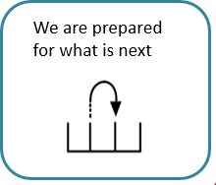 | We will listen to instructions so we know what to do next. We will use the visual timetable to help us know what is next.  We will ask for more information or for the information again if we are unsure. We will calmly transition to our next learning.  We have everything we need for what is next or ask for it. We will keep our learning space tidy and organised.  We will think about what is coming next so we are ready and prepared.  We will drink water and go to the toilet at sensible times so as not to disturb the learning.  We will be helpful around the class in preparing for what is next. We will help others be prepared too e.g. pass sheets/resources.

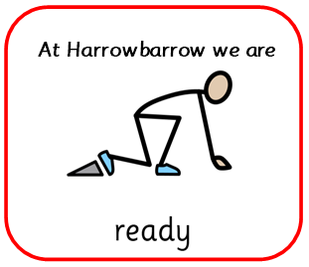 | 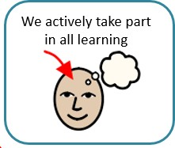 | We approach things with energy and enthusiasm. We are willing to have a go.  We engage in class discussions and ask the teacher and other children questions. We share our prior knowledge and experiences.  We take pride in our learning and progress. We reflect on our achievements and progress.  We recognise our barriers and ask for help when we don’t understand.
 | 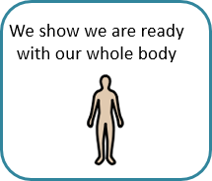 | We use SLANT (Sit Up, Listen attentively, Ask Questions, Never interrupt, Track the teacher/speaker).  We look and listen to the speaker.  We come to class with a positive mental attitude.  We copy adults by putting our hand up to show we are ready.  We make sure we are ready by taking care of our physical needs to make us prepared.  We are comfortable in our body. We use positive body language.  We are where we are supposed to be. We ask for or use a strategy to be ready. We wear our school uniform proudly.
 | 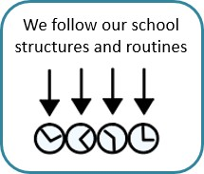 | We walk proudly on the left in single file. We meet and greet those around me.  We keep our belongings on our labelled pegs, chairs or in our trays. If we notice someone else’s belongings on the floor we will pick them up and re-hang them.  We go straight to where we need to go.  We use our manners and hold doors open for others. We line up in a straight and quiet line.  We transition to and from the carpet calmly.  We go to the toilet or have a drink at a ‘sensible time’.  We carry out our Year 6 Learning Ambassador jobs, if we have one, to the best of our ability.  We sit or stand in our carpet/table spot.  We respond as soon as possible to adult 3, 2, 1 ready countdowns.

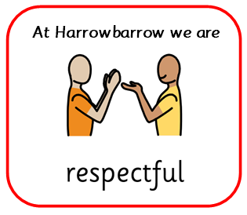 | 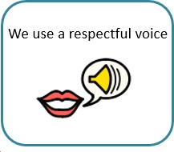 | We speak in an appropriate tone. We speak at an appropriate volume. We use a kind and polite tone.  We greet each other respectfully  We use appropriate language (words) for school.  We use people’s names when we are talking to them. We face the person we are listening to or talking to.  We always respond respectfully and take the time we need to be able to do this successfully.
 | 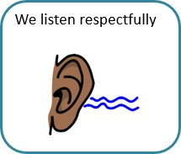 | We look at the person talking.  We wait for the person who is speaking to finish before using agree and disagree hand gestures.  We engage in the conversation by asking and answering relevant questions. We listen to everyone respectfully.  We build on and respond to what others have said verbally and using Harrowbarrow hand gestures.  We show we are listening with my body.  We allow others the opportunity to speak and listen to them.  We communicate respectfully if we are not ready to listen, and take action when we are ready.  We know that only one person should talk at a time.
 | 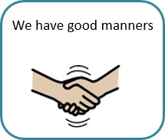 | We use our Harrowbarrow manners (name, thank you, excuse me, please, smile).  We greet people when we meet them.  We say excuse me or pardon if we didn’t hear what was said.  We hold open doors for people – we will say thank you and please. We help others and ask others if they need help.  We use cutlery in the lunch hall.  We takes turns and share resources and equipment. We allow others to go before us.  We apologise sincerely.  We use eye contact when we speak with someone.  We listen when others are talking and giving their ideas. We use kind words at school.  We consider and be aware of the differences of others and their needs.  We ask questions of others and show interest in them.

 | 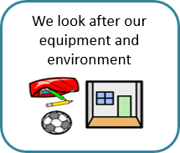 | We proudly wear our uniform every day and take responsibility for it. We are proud of our school and look after it.  We understand the importance and value of equipment and look after it. We use all areas of the school sensibly including the toilets.  We respect the nature and the plants in the school grounds.  We keep the outdoor environment tidy by picking up litter and using the bins.  We tell an adult if something is broken so it can be fixed. We help put things away.  We look after our own equipment and possessions.
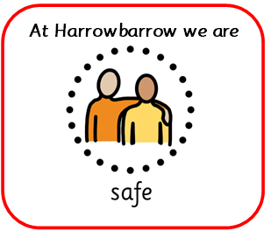 | 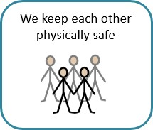 | We keep our hands and feet to ourselves.  We check on other children if they appear hurt.  We use equipment and resources correctly and sensibly. We walk calmly and sensibly inside of school.  We move safely outside of the school. We manage our own physical risks.  We ask an adult for help if someone feels physically unsafe. We keep our ‘hands off,’ others.  We keep our ‘feet off,’ others.  We make sure all touch is appropriate and ask permission where necessary.  We respect the personal space of others.
 | 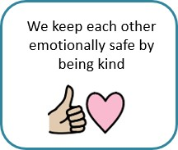 | We ask others how they are.  We notice if others need support and offer kindness and support when it’s needed.  We compliment others.  We know strategies we can use if we feel uncomfortable.  We are aware of the different ways people communicate, when happy or sad. We understand and respect that everyone is different.  We ask permission before asking personal questions and will respect the privacy of others.  We respect others’ boundaries and sensitivities. We know we can say if we are uncomfortable.

 | 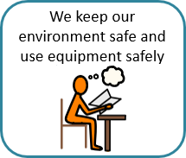 | We leave the environment how we would like to find it. We pick things up off the floor and keep things tidy.  We use scissors safely and appropriately.  We use equipment and resources in areas it is safe to use them. We sharpen our pencils at a sensible time.  We tuck in our chairs.  We use the internet safely and know who to ask if we feel uncomfortable. We take pride in our work books and look after the books in the school.
 | 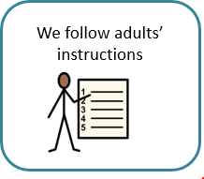 | We listen and respond promptly. We respect adult instructions.  We ask for an explanation if we have misunderstood or we are confused in a respectful way.  We know there are different types of instructions to follow. We listen to instructions fully.  We use other resources (such as resources available or the working walls) if we are not sure before asking for help.

Appendix 2a: Systems which support behaviour within the classroom

All classes will ensure:

- Pupils follow expectations for lining up, when transitioning. This should include facing the front, standing in silence and looking towards the adult who will be stood at the front.
- Carpet spaces for children to be known and displayed (infants)
- Classroom monitors/helpers chosen to undertake tasks in class e.g. giving books and equipment out
- Named coat pegs and trays for individual children (infants)
- Table and seating plan
- Visual timetable displayed and a shared at the start of the day
- Labelled water bottles in box (Hydration Station) – (infant)
- Stationery pots for each table which groups are responsible for maintaining e.g replacing pen lids
- Whole class, group or individual sensory breaks at regular times

Appendix 2b: Reward systems
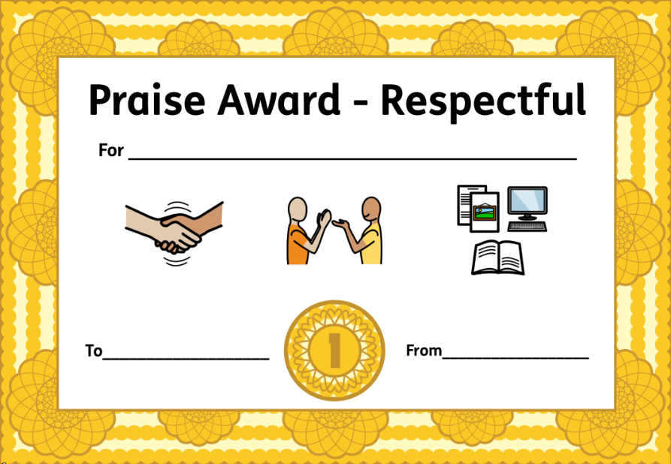
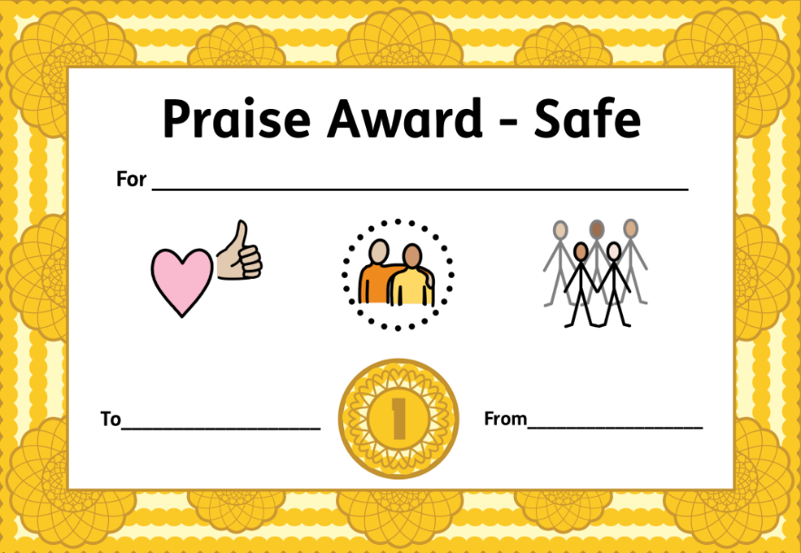
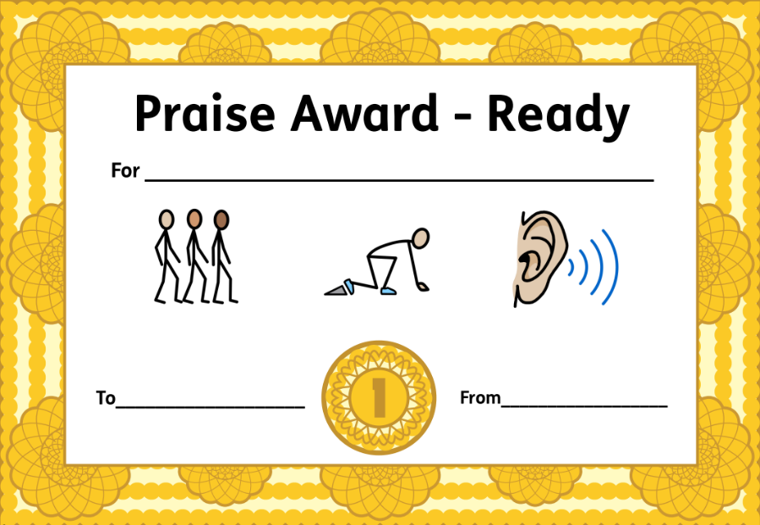

Appendix 3a: Step Chart

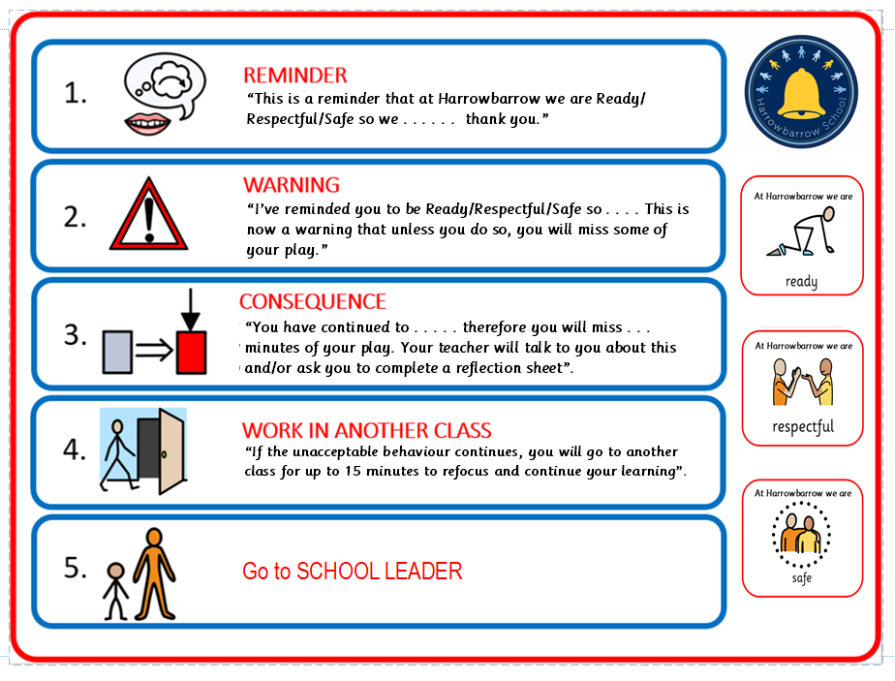
Appendix 3b: Reflection Sheet

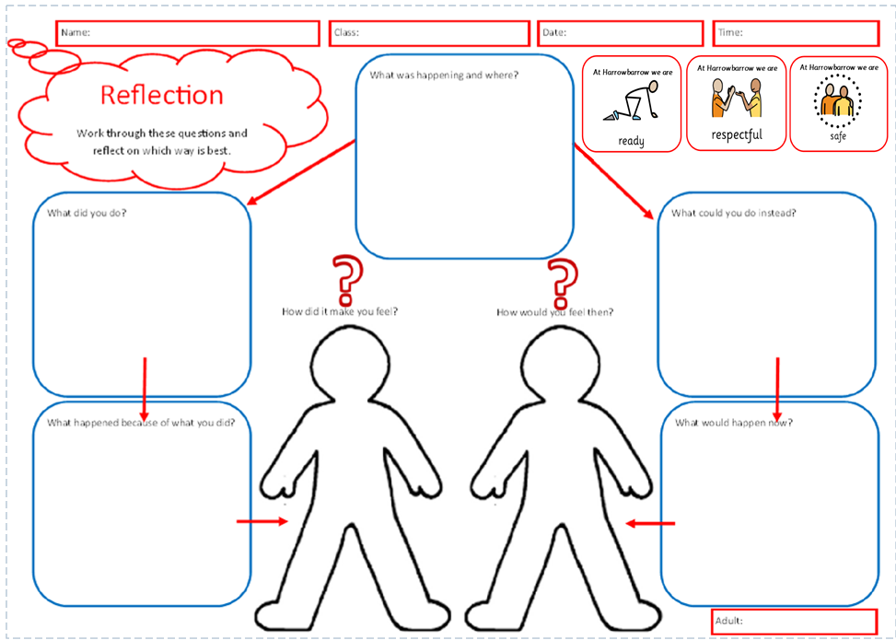
Appendix 3c: Receiving a child into class and back into class

Step 4- Receiving a child into your class
- This is time to calm, no blame or judgement is needed, this is a process. It allows the child to move on and return after no more than 15 minutes.
- The children sit at a desk and continue their learning.
- Receive them quietly and calmly and as privately as possible. Step 5 – sent to SLT member
- Re-set high expectations
- Consequence (this may be a verbal reprimand, loss of privileges, school based community service such as tidying a space, collecting rubbish, cleaning desks (opportunity for repair, choosing to do something positive)
- Reflection activity (proforma)
- Repair
- Restorative conversations- this may also include an apology. This leads to a ‘clean slate’ SLT will then rehearse a script with the children and then walk them calmly back to class.
SLT will tell the teacher the steps that have been taken whilst the child was out of class and that the child is ready to return. Child will apologise, ‘I am sorry for XXX please can I return to the classroom and my learning.’

- The role of the teacher is to accept the child positively back into the classroom with no further chastising which would undo the work done by SLT.
- A restorative conversation at the next appropriate time such as play time between the teacher and child when appropriate.
- If the teacher is in mid-teaching flow, the SLT will wait outside the classroom with the child whilst the teacher tasks class with an appropriate activity so they can receive the child back.
- Dependent on the child, SLT may request Emotional Health & Wellbeing Support Worker to complete some of these stages.
- Call home to report behavior by the class teacher or SLT depending on the incident. Teacher to log MyConcern incident.

Receiving your child back from another class or Phase Lead class
- The child will say, ‘I am sorry for XXX please can I return to the classroom and my learning’.
- Teachers are to be positive and welcoming.
- Their role is to accept the child back in without further chastisement.

Appendix 3d: Behaviour and sanctions chart

At Harrowbarrow our ultimate goal is positive behaviour established through consistency, clear systems and routines and high expectations. When serious misbehaviour and incidents arise we recognise it needs to be responded accordingly with a clear message that it is not tolerated at Harrowbarrow. The wider context including the circumstances of the incident, the child’s contextual factors, including age and stage, and any special educational needs or disabilities are always considered alongside any decision making using this framework.

 | Behaviour | Adult | Actions and Sanctions | MyConcern
Low Level | Low level disruptions | Class teacher |  | Completed by
 |  |  |  | class teacher
 | - Out of seat  - Calling out  - Silly noises/ faces  - Using equipment intentionally inappropriately/ incorrectly (e.g. rocking on |  |  | at Step Three
 | chair)  - Interrupting  - Unwanted touching  - Running inside the building  - Fidgeting  - Not following instructions  - Turning around and looking the wrong  - Intentionally not being on task (e.g. not completing learning, loitering at the |  | - Follow 5 step system:  - Step1: Reminder  - Step 2: Warming  - Step 3: Consequence  - Step 4: Time in another class  - Step 5: Senior Leader intervention
pegs)
- Not being respectful (e.g. negative body language)
Tier 1 | Challenging negative behaviour | Class teacher/ Support staff (where appropriate) | An appropriate action(s) and/or sanction from the list below that is appropriate and proportionate | Completed by
 |  |  | to the behaviour | class teacher
 | - Pushing in line  - Low level name calling  - Play fighting  - Refusal to complete work or follow instructions  - Deliberately breaking schools or others’ property  - Negative verbal or physical response  - Inappropriate language including swearing  - Unintentionally hurting someone as a result of another negative action/ |  | - Step 3: Miss 5 minutes of break time  - Step 3: Reflection sheet and restorative conversation  - Step 3: Discreet discussion with parent/ phone call home from class teacher  - Step 4: Time in another classroom to continue learning/ reflection sheet  - Right the wrong e.g. Apology letter
behaviour
- Spitting
Tier 2 | Serious and deliberate | Phase Leads | An appropriate action(s) and/or sanction from the list below that is appropriate and proportionate | Completed by
 |  |  | to the behaviour | class teacher
 | - Persistent challenging negative behaviour  - Persistent or serious rudeness/ name calling  - Swearing at someone  - Graffiti/ vandalism  - Stealing  - Intentionally hurting someone  - Verbal or physical threat  - Spitting at someone  - Inappropriate online behaviour |  | Musts:  - Step 5: Sent to Senior Lead or time in Senior Lead’s classroom  - Discreet discussion with parent/ phone call home from teacher  - Reflection sheet and restorative conversation (suggestion first 10 minutes of lunchplay)  - It it’s the teacher’s responsibility to “investigate” the behaviour through questioning those involved. Only when it is determined to be serious and deliberate should SLT be involved.  Consequence toolkit:  - Miss whole of break time  - Right the wrong e.g. clean up graffiti  - Harrowbarrow Repair (community service) e.g. picking up rubbish, supporting chef or PE | Phase Lead add action where appropriate
teacher
- Phase lead meeting with parent
- Removal of a privilege (this cannot affect their access to a full curriculum.
 |  |  | Examples might include sports team training session, music club, attendance at
 |  |  | year group events and whole school events)
Support toolkit:
- TAC
- Cause for Concern
- SEMH intervention programme
- Individual Behaviour Plan
Tier 3 | Extremely serious | SLT | An appropriate action(s) and/or sanction from the list below that is appropriate and proportionate | Completed by
 |  |  | to the behaviour | SLT
 | - Bullying including online  - Discrimination (including all protected characteristics) and oppressive behaviour  - Sexual harassment and sexual violence  - Very serious challenge to adult  - Intentionally seriously hurting someone  - Persistent serious and deliberate behaviour  - Serious inappropriate online behaviour  - Possession of any prohibited items  - Fighting  - Any activity that makes other children feel unsafe |  | Musts:  - Blue Card to SLT for serious behaviour disrupting lesson OR a safety situation  - Escalation to SLT at most appropriate time (out of lesson time if possible)  - Meeting with parent Consequence toolkit:  - Removal of a privilege (this cannot affect their access to a full curriculum. Examples might include sports team membership, attendance at year group events and whole school events, removal of Y6 varsity jacket)  - Harrowbarrow Repair (community service) e.g. picking up rubbish, supporting chef or PE teacher  - Fixed term internal suspension (work to be planned by class teacher)  - Fixed term external suspension (work to be planned by class teacher)  - Permanent exclusion (work to be planned by class teacher)
Support toolkit:
- TAC
- Cause for Concern
- SEMH intervention programme
- Reintegration support and meeting (if suspended)
- SEMH intervention programme

Appendix 3e: Harrowbarrow Manners
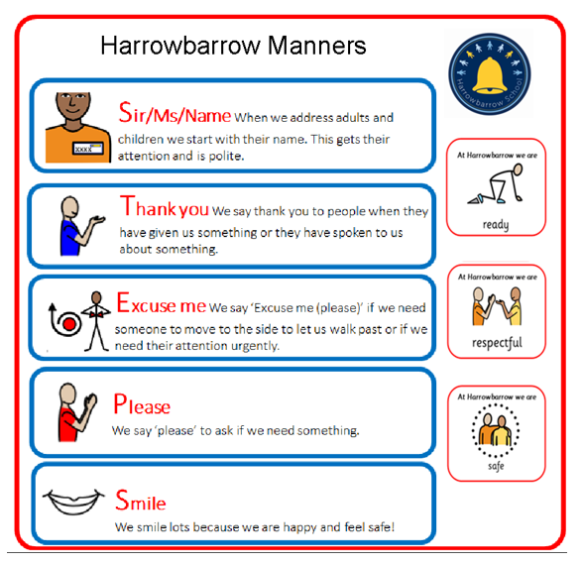

Appendix 4a: Expectations for moving around school

Walk proudly!
Walk in single file to the left calmly and quietly (just above a whisper if you need to say something) Adults and children use quiet voices in corridors too.
Hold doors open for one another. Go straight to where you need to go.
Use your manners by saying ‘hello’, ‘good morning’, ‘pardon’, ‘excuse me’. Pick up any coats/bags off the floor and re-hang.

Transitioning into class

Teachers positively ‘meet and greet’ children at the classroom door, and have a ‘do now’ prepared for the children to access independently in order to settle them quickly.

Class teachers are ready promptly to greet children at the classroom door at 8.40am in the morning, 10.30am or 10.50am in the playground after morning play, and 1pm at the end of lunch time.

Assemblies

Teachers bring children to assembly and settle them. Where possible, classes have a focus adult with them during assembly. All children are collected from assembly and walked back to class.

Cloakrooms

TAs/staff to be present in cloakrooms at transitions. Names on pegs.
Look at peg positioning to minimise incidents.
Staggered entry and exit – a few children at a time.

At Harrowbarrow we believe that when children are closely monitored they behave better.

Appendix 4b: Playtime Behaviour (mornings/lunches and wet play)

When there is negative behaviour the following procedures will apply:

If the behaviour is low level, such as intentionally not using equipment correctly, then the step system will be used in the same way as the classroom and they be redirected with their play.
- Step One – Reminder of the expected behaviour e.g.: “This is a reminder that at Harrowbarrow we are Ready/Respectful/Safe so
……. Thank you.”
- Step Two – Verbal warning - “I’ve reminded you to be Ready/Respectful/Safe so ……. This is now a warning that unless you do so, you will have to play (with) something different.”
- Step Three – Consequence - The child will be redirected in their play e.g. “You have continued to use the equipment incorrectly therefore you will need to choose another piece of equipment to play with.” This must be followed through. This then marks a ‘clean slate’.
- Step Four/ Five – If the low level disruption continues the child will be sent to a member of the SLT.

If there is a dispute between children then the following approach will be used:
- Adult led restorative discussion

If the incident is more serious, for example a child intentionally seriously hurting another child, then the staff member will take the following steps:

- The lunchtime staff will ask the child to move away from the situation into an area of playground which is quieter and away from their peers.
- The lunchtime staff will move down to the level of the child and adopt open neutral body language (e.g. not folding arms or putting hands on hips), standing at a respectful distance to the child to initiate a discussion.
- Regardless of the child’s actions, the member of staff will remain calm and use a talking voice to speak to this child using the language of Ready/ Respectful/ Safe. Shouting is never acceptable.
- If the child is unable to respond to the adult, the adult will give the child an appropriate amount of time (e.g. a few minutes) to cool down until they are already to articulate what happened.
- The member of staff will listen to the child and will not jump to conclusions.
- If a staff member needs to communicate with another member of staff to explain a situation, then they will do this in private without the child being able to hear them. As above, the adult will not use emotive language to describe what happened but rather stick to the facts.
- Where appropriate, the lunchtime staff will use an approach to address the situation e.g. “right a wrong”, restorative approach, redirection of play. At the end of lunchtime, following resolving the situation, the lunchtime staff will report any serious incidents or recurrent incidents to SLT o class teachers or a member of the SLT so they can be recorded on MyConcern and followed up where necessary.
- However, if a situation is serious the lunchtime staff will involve the SLT in resolving the situation. The child may be asked to miss some of their lunchtime by spending time with the SLT or outside the staffroom and details will be recorded on MyConcern.
- Any negative behaviour will be reported to the class teacher at the end of the playtime.

Managing serious incidents whilst on the playground

If there is a physical fight or a child who is dysregulated and is putting themselves or others at risk:

- Send a child to find a member of the SLT with the message, ‘playground assistance is needed’. If there is no member of staff avialble, then the child will need to go to the staffroom or main school office - staff will immediately contact a senior staff member or someone with behavioural expertise.
- Remove the other children calmly.
- Speak calmly and with authority to the child in need:
- STOP.
- YOU NEED TO BE READY/ RESPECTUFUL/ SAFE
- LET ME HELP YOU
- FOLLOW ME
- EVERYTHING WILL BE FINE – when appropriate to the context/incident
Repeat this sequence to calm the situation. Particularly the last three statements. Senior staff will arrive to help.

Appendix 4c: Wrap-around and extra-curricular club behaviour

When there is negative behaviour the following procedures will apply:

If the behaviour is low level, such as intentionally not using equipment correctly, then the step system will be used in the same way as the classroom and they be redirected with their play/ activity.
  - Step One – Reminder of the expected behaviour e.g.: “This is a reminder that at Harrowbarrow we are Ready/Respectful/Safe so
……. Thank you.”
  - Step Two – Verbal warning - “I’ve reminded you to be Ready/Respectful/Safe so ……. This is now a warning that unless you do so, you will have to play (with) something different.”
  - Step Three – Consequence - The child will be redirected in their play/ activity e.g. “You have continued to use the equipment incorrectly therefore you will need to choose another piece of equipment to play with.” This must be followed through. This then marks a ‘clean slate’.
  - Step Four/ Five – If the low level disruption continues the child will be sent to a member of the SLT.
  - If there is a dispute between children then the adult will lead a restorative discussion.
If the incident is more serious, for example a child intentionally seriously hurting another child, then the staff member will take the following steps:

  - The club staff member will ask the child to move away from the situation into an area which is quieter and away from their peers (whilst following safeguarding guidance)
  - The club staff member will move down to the level of the child and adopt open neutral body language (e.g. not folding arms or putting hands on hips), standing at a respectful distance to the child to initiate a discussion.
  - Regardless of the child’s actions, the member of staff will remain calm and use a talking voice to speak to this child using the language of Ready/ Respectful/ Safe. Shouting is never acceptable.
  - If the child is unable to respond to the adult, the adult will give the child an appropriate amount of time (e.g. a few minutes) to cool down until they are already to articulate what happened.
  - The member of staff will listen to the child and will not jump to conclusions.
  - If a staff member needs to communicate with another member of staff to explain a situation, then they will do this in private without the child being able to hear them. As above, the adult will not use emotive language to describe what happened but rather stick to the facts.
  - Where appropriate, the club staff member will use an approach to address the situation e.g. “right a wrong”, restorative approach, redirection of play. At the next opportunity, following resolving the situation, the club staff member will report any serious incidents or recurrent incidents to the SLT so they can be recorded on MyConcern and followed up where necessary.
  - However, if a situation is serious the club staff member will involve the SLT in resolving the situation.

MyConcern

Negative behaviour reported by the club staff member which will need to be record on MyConcern.
Managing serious incidents at wrap-around and extra-curricular club sessions:
If there is a physical fight or a child who is dysregulated and is putting themselves or others at risk:

- Send a child to the school office or SLT with the message, ‘assistance needed at . . . club’.
- Remove the other children calmly.
- Speak calmly and with authority to the child in need:
- STOP.
- YOU NEED TO BE READY/ RESPECTUFUL/ SAFE
- LET ME HELP YOU
- FOLLOW ME
- EVERYTHING WILL BE FINE – when appropriate to the context/incident

Appendix 5: Early Years Foundation Stage (EYFS)

Key Values

At Harrowbarrow we believe our children are unique individuals. They have the right to a safe, challenging learning environment that inspires curiosity and is tailored to their interests. We aim to nurture self-belief, provide an individualised curriculum and have high expectations for all learners. By working together, we will develop strong foundations for future learning.

We follow the whole school principals and teach the children that we are ready, respectful and safe. Throughout the principals we are also encouraging the children to do the following:

1. We use kind words- we tell the truth and say nice things to each other.
2. We are helpful and kind- we tidy up and take turns.
3. We listen to each other and work together to solve problems
4. We look after our toys, the books and the environment.
5. We try new things.

How we encourage positive behaviour

• Clear Routines – visual timetables are displayed in the classroom, children are familiar with the routines and made aware of any changes.
• Support at Tidy Up time – reminders, bell indicates tidy up time, children are encouraged to help, children are praised.
• Carpet Times- resources are prepared, visual aids encourage good listening, good looking.
• Lining Up- children are met at the door by an adult to be brought inside. Children walk when in a line.
• Practitioners use positive, specific praise e.g. “Thank you for giving the toy to your friend, you have been kind”.
• There are enough resources, equipment and materials.
• Stories are read that highlight caring, consequences and feelings.
• Practitioners know the needs of the children; differentiate, use of interests, behaviour is discussed at EYFS planning meetings.
• Children with behavioural needs have individualised strategies; social stories, individual plans.
• Adults in the EYFS recognise that they are role models for good behaviour.
• Positive relationships are built between parents/carers, the child and key person – home visits, transition workshops, parent’s meetings, staggered starts.
• Limit Setting- we have age appropriate limitations and expectations for the child’s development.

Strategies

Approaches for negative behaviour

  - Use a calm, firm, controlled voice.
  - Use Makaton (where necessary) and visual cards.
  - Get down to eye level and insist on eye contact if appropriate to that child.
  - Deals with behaviour immediately; don’t prolong or give unnecessary attention.
  - Label the behaviour rather than the child e.g. “that was unkind” rather than “you are unkind”.
  - Praise positive behaviour.
  - Offer a choice.
  - Redirect children to a more appropriate activity.
  - Children are encouraged to express their feelings and are praised for doing so.
  - Rules are explained to children.
  - Teach children to negotiate; say “no”, say “stop I don’t like it” or seek an adult if they need help.
  - Speak to the child’s key person/child brought to key person.

Approaches when child is breaking the rules or putting themselves at risk:
- Intervene in a calm manner.
- Tell them to ‘Stop’ or ‘No’ – use Makaton (where necessary) or a visual card if needed.
- Bend, kneel or sit down so you are at their eye level.
- Tell the child calmly and clearly what they have done and that you do not want it to happen again.
- Offer an explanation or alternative to the child- work with them to negotiate or find a solution.
- Use the consequences of their actions to help them learn.

Conflict resolution:
- Approach the child/children at eye level in a calm manner.
- Acknowledge their feelings- use visuals.
- Gather information – from all children.
- Restate the problem.
- Facilitate them to find a solution or give them choices e.g. comforting the child, fetching tissues.
- Support children as they rejoin play- follow up support needed.

Consequences and actions - as a last resort

If the strategies have not worked the child is warned that if the behaviour continues the child will spend some time in another area of the EYFS environment.

If the behaviour continues or in cases where the child is a danger to themselves or others they will be removed from the situation and will spend time with a member of the SLT. The child will be supported by an adult when being reintroduced to their play after clear behaviour expectations have been discussed.

Parental Involvement

In all cases of negative behaviour a conversation will be had with the child’s parents or guardians. This may be at the door in the morning or afterschool, or a phone call if the child attends breakfast and afterschool club. Sometimes a phone call or meeting may also be requested if the behaviour is more serious and a longer discussion needs to take place.

