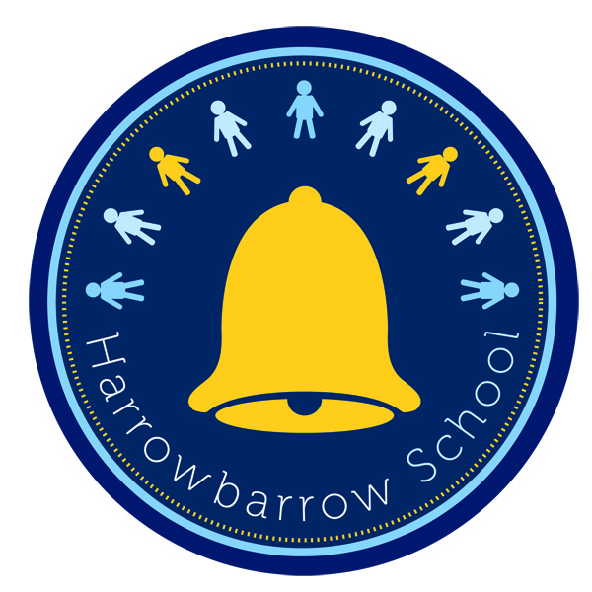
HARROWBARROW SCHOOL
Administering Medicines

This policy sets out the guidance by which the school will administer medicines. For more detailed information please refer to the DCFS document ‘Managing medicines in schools and early years settings: March 2003’.

Managing prescription medicines during the school day

Many children will need to take medicines during the day at some time during their time in a school or setting. This will usually be for a short period only, perhaps to finish a course of antibiotics or to apply a lotion. To allow children to do this will minimise the time that they need to be absent. Medicines should only be taken to school when essential; that is where it would be detrimental to a child’s health if the medicine were not administered during the school ‘day’. The school will only accept medicines that have been prescribed by a doctor, dentist, nurse prescriber or pharmacist prescriber. Medicines should always be provided in the original container as dispensed by a pharmacist and include the prescriber’s instructions for administration and dosage. The school will not accept medicines that have been taken out of the original container.
The school will never give a non-prescribed medicine to a child unless there are exceptional circumstances and parents have requested agreement from the Headteacher. If children are unwell parents should keep them at home.

Where children have long term medical needs, the school will need to be informed before the child is admitted, or when a child first develops this medical need. For children who attend hospital appointments on a regular basis, special arrangements may also be necessary. It is often helpful to develop a written health care plan for such children, involving the parents and relevant health professionals. This can include:

• details of a child’s condition
• special requirement e.g. dietary needs, pre-activity precautions
• and any side effects of the medicines
• what constitutes an emergency
• what action to take in an emergency
• what not to do in the event of an emergency
• who to contact in an emergency
• the role the staff can play

Roles and responsibilities of staff

The Headteacher is responsible for making sure that staff have appropriate training to support children with medical needs. They should also ensure that there are appropriate systems for sharing information about children’s medical needs in. The Headteacher should satisfy themselves that training has given staff sufficient understanding, confidence and expertise and that arrangements are in place to up-date training on a regular basis. A health care professional should provide written confirmation of proficiency in any medical procedure.

The Headteacher should make sure that all parents and all staff are aware of the policy and procedures for dealing with medical needs. The head will ensure that the appropriate systems for information sharing are followed. This will include keeping up to date healthcare files in each class so that permanent and temporary staff have relevant healthcare information about their cohort. For children with long-term or more serious medical needs, important information will be signposted from the staffroom noticeboard.
Any member of staff giving medicines to a child should check:

the child’s name
prescribed dose
expiry date
written instructions provided by the prescriber on the label or container

If in doubt about any procedure staff should not administer the medicines but check with the parents or a health professional before taking further action. If staff have any other concerns related to administering medicine to a particular child, the issue should be discussed with the parent, if appropriate, or with the school nurse.

Members of staff administering medicines are covered by the Local Authorities ‘Employers Liability Insurance’, as long as they have received appropriate training e.g. administering insulin.

Parental responsibilities

Parents, as defined in section 576 of the Education Act 1996, include any person who is not a parent of a child but has parental responsibility for or care of a child. In this context, the phrase ‘care of the child’ includes any person who is involved in the full-time care of a child on a settled basis, such as a foster parent, but excludes baby sitters, child minders, nannies and school staff.
Parents should be given the opportunity to provide the head with sufficient information about their child’s medical needs if treatment or special care needed. This will be requested on the child’s entry to the school using Form 2.

Parental permission

Parents must formally request that medicines are administered using the appropriate forms: 3A or 3B. Without the appropriate consent, medicines cannot be administered by the school. Forms can be requested through the school office and records are kept in the ‘Administering Medicine’ file.

Assisting children with long term or complex medical needs

The main purpose of an individual health care plan (Form 2) for a child with medical needs is to identify the level of support that is needed. An individual health care plan clarifies for staff, parents and the child the help that can be provided. It is important for staff to be guided by the child’s GP or paediatrician. Staff should agree with parents how often they should jointly review the health care plan. It is sensible to do this at least once a year, but much depends on the nature of the child’s particular needs; some would need reviewing more frequently.

Pupils who manage their own medicines

Older children with a long-term illness should, whenever possible, assume complete responsibility under the supervision of their parent. Children develop at different rates and so the ability to take responsibility for their own medicines varies. This should be borne in mind when making a decision about transferring responsibility to a child or young person. There is no set age when this transition should be made. There may be circumstances where it is not appropriate for a child of any age to self-manage. Health professionals need to assess, with parents and children, the appropriate time to make this transition. If children can take their medicines themselves, staff may only need to supervise. Parental agreement (Form 3A) will indicate whether children may carry, and administer (where appropriate), their own medicines, bearing in mind the safety of other children and medical advice from the prescriber in respect of the individual child.

Staff training

Where appropriate, staff will receive training from health professionals in the giving of medicines e.g. use of asthma inhalers, giving insulin etc. For more general administration of medicines e.g. prescribed antibiotics, staff will follow the printed instructions on the label or container.

Record keeping

Prescribed medicines will only be administered by a designated member of staff once either Form 3A or 3B have been collected. Parents of children who have long term medical needs will need to complete Form 2 on entry or when a condition has been newly diagnosed. Parents will also need to indicate on this form what to do in the event of an emergency. Whenever medicines have been administered a record will be kept by the designated member of staff responsible using Form 6.

Safe storage of medicines

Large volumes of medicines will not be stored. Staff will only store, supervise and administer medicine that has been prescribed for an individual child. Medicines should be stored strictly in accordance with product instructions (paying particular note to temperature) and in the original container in which dispensed. Staff will ensure that the supplied container is clearly labelled with the name of the child, the name and dose of the medicine and the frequency of administration. This should be easy if medicines are only accepted in the original container as dispensed by a pharmacist in accordance with the prescriber’s instructions. Where a child needs two or more prescribed medicines, each should be in a separate container. A few medicines need to be refrigerated. They will be kept in the staffroom refrigerator but should be in an airtight container and clearly labelled.
All emergency medicines, such as asthma inhalers and adrenaline pens, should be readily available to children and should not be locked away.

First agreed by governors: October 2010
Last reviewed: December 2018
Next review: October 2023

