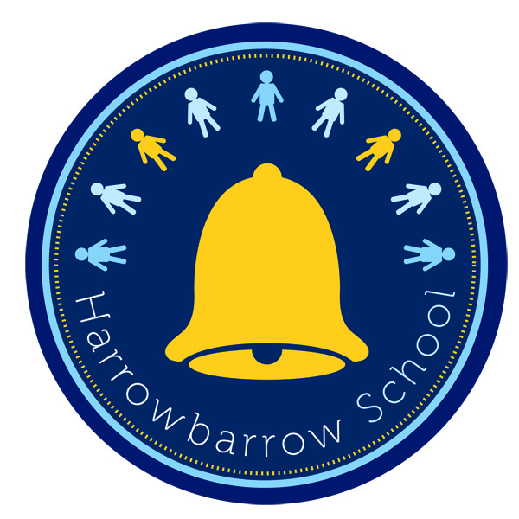
HARROWBARROW SCHOOL
Science Policy

Intent
The 2014 national curriculum for science aims to ensure that all pupils:

- Develop scientific knowledge and conceptual understanding through the specific disciplines of biology, chemistry and physics.
- Develop understanding of the nature, processes and methods of science through different types of scientific enquiries that help them to answer questions about the world around them at the same time as predicting what has happened and what will happen next.
- Understand that science has changed our lives and is vital to the world’s future prosperity.

At Harrowbarrow, we understand the importance to prepare children for life in an increasingly scientific and technological world. We aim for science lessons to promote children to be inquisitive about the world around them, thus encouraging children to foster concern about the local and global environment. We ensure that the working scientifically skills are at the forefront of our science curriculum and developed throughout children’s time at the school so that they can apply their knowledge of science in a variety of situations, not just in the classroom. Throughout the programmes of study across the school, the children will acquire and develop the key knowledge that has been identified within each unit and across each year group, as well as the application of scientific skills.

Implementation

Teachers are expected to create a positive attitude to science learning within their classrooms and reinforce an expectation that all pupils are capable of achieving high standards in science. Our whole school approach to the teaching and learning of science involves the following;

- Medium term planning will outline the areas of science that will be taught during the term to ensure coverage of our whole school skills progression document.
- Within short term planning, clear success criteria for each learning objective taught should be based on our skills progression document, therefore allowing accurate planning that ensures progression, not only in an individual lesson, but also in a series of lessons.
- Where children are working significantly above or below the objective, objectives should be adapted in order to meet the individual’s needs, including providing scaffolding to allow children to achieve objectives or by allowing children to research challenging key questions or enquiries independently to allow them to develop mastery of the objective.
- Class teachers should regularly plan for opportunities for children to apply their scientific skills to different areas within science lessons and across the curriculum. This will also allow children to revisit, practice and consolidate different areas of science and apply them within different contexts.
- Planning should involve real life contexts for science, where children are investigating scientific questions with a real purpose in mind, appropriately linked to the creative curriculum topic. Children are encouraged to ask their own questions and be given opportunities to use their scientific skills to challenge misconceptions.
- Enquiry-based learning should permeate the scientific knowledge and understanding being developed by the teacher, as it gives life and sustenance to learning new knowledge and developing understanding in every area of the primary science curriculum. It should be the driving force of scientific learning, teaching and assessment, enabling children to be far more independent and scientific in their thinking and approach to science.
- Teachers demonstrate how to use scientific equipment, and the various Working Scientifically skills in order to embed scientific understanding. Teachers find opportunities to develop children’s understanding of their surroundings by accessing outdoor learning and workshops with experts.
- Children are offered a wide range of extra-curricular activities, visits, trips and visitors to complement and broaden the curriculum. These are purposeful and link with the knowledge being taught in class.
- Children are given opportunities to use ICT (video, digital camera, data logger) to record their work, thus adding to the engagement and accessibility of the task.

Impact

The impact of implementing Science in this way will mean that Harrowbarrow School provides fun, engaging, high-quality science education, that develops pupils’ enjoyment and interest in science, at the same time as developing their appreciation of its contribution to all aspects of everyday life. Our engagement with the local environment in lessons ensures that children learn through varied and first hand experiences of the world around them. Frequent, continuous and progressive learning outside the classroom is embedded throughout the science curriculum. Through various workshops, trips and interactions with experts and local charities, children have the understanding that science has changed our lives and that it is vital to the world’s future prosperity. Children learn the possibilities for careers in science, as a result of our community links and connection with national agencies such as the STEM association and learn from and work with professionals, ensuring that children have access to positive role models within the field of science from the immediate and wider local community. From this exposure to a range of different scientists from various backgrounds, all children feel that they are scientists and capable of achieving. Children at Harrowbarrow will overwhelmingly enjoy science and this results in motivated learners with sound scientific understanding.

Differentiation and Additional Educational Needs
The study of science will be planned to give pupils a suitable range of differentiated activities appropriate to their age and abilities. Tasks will be set which challenge all pupils, including the more able. For pupils with SEN, the task will be adjusted or pupils may be given extra support. The grouping of pupils for practical activities will take account of their strengths and weaknesses and ensure that all take an active part in the task and gain in confidence.

Cross curricular links and skills

Science permeates every aspect of our lives and we will relate, where possible, to the teaching of other subjects in a cross curricular fashion. We will also ensure that pupils realise the positive contribution of both men and women to science and the contribution from those of other cultures, correcting possible misconceptions and stereotypes. We will not only emphasise the positive effects of science on the world but also include problems, which some human activities can produce.

Assessment
Throughout the school, teachers will assess whether children are working at, above or below the expected level for their age based on their understanding and application of the content of the National Curriculum 2014. Prior knowledge is assessed at the beginning of each topic through an elicitation type activity, such as a mind mapping or teacher questioning. Assessment is then on-going throughout the series of lessons thus informing future planning both short term and long term.

Resources
There is a central resource area which includes equipment that can be used during experiments and investigations. Resources are labelled clearly and re-checked every year. For each topic, there is a list of useful websites, teaching resources and lesson ideas stored on Google Drive in a shared folder available to all members of teaching staff.
Health and safety

Pupils will be taught to use scientific equipment safely when using it during practical activities. Class Teachers and Teaching Assistants will check equipment regularly and report any damage, taking defective equipment out of action.

Responsibilities
Head Teacher/ Deputy Head: Responsible for the overall curriculum development and monitoring of teaching.
Subject Coordinator:
- Ensures that there is a breadth of coverage with accurately linked planning across all year groups that meets the needs of all learners.
- Monitors the quality of teaching and learning covered through observations of lessons, reviews of teacher’s plans and termly book scrutiny.
- Responsible for ensuring the development of subject resources, progression of skills and the curriculum.
- Supports the staff in planning for and teaching Science.

Teacher: Individual teachers are responsible for implementation of each subject policy. They are responsible for planning appropriate learning experiences that teach key skills whilst developing the required knowledge and understanding. Teachers are responsible for assisting the coordinator in the monitoring and recording of pupil progress in each subject.
Review and Evaluation
This policy was edited in January 2021 by Science Coordinator, Mr Sam Watts. It will be reviewed annually.

