Christmas Tea Towels

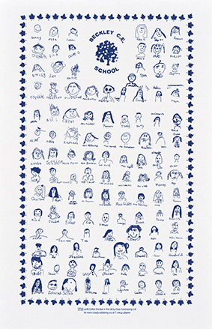
Dear Parent/Carer
This year the PSA has arranged for the children to design a tea towel with their faces and names on it. These will be sold to parents instead of the usual Christmas cards and decorations.
The above picture is an example of how our tea towel will look
We are selling each tea towel for £5.00 and Parents/Carers are invited to order these in time for Christmas.
These will make perfect Christmas presents for loved ones and they will last for years to come.
All order forms for tea towels along with all monies are required by Monday 9th December 2019. Unfortunately, due to timescales, any orders made after the cut-off date of Monday 9th December 2019 won’t be able to be added to our order.
The order form for the tea towels is printed below.
Best Wishes
Michelle O’Neill
PSA Chair
-----------------------------------------------------------------------------------------------------------------------------
Tea Towel Order Form

Parent’s Name………………………………………………(PLEASE PRINT)

I would like to order tea towels @ £5.00 each.

I enclose payment of £_____ cash/cheque

*Once received please give to ………………………………….. (child’s name) Class………………..
*I will collect from the school office
*Please delete as appropriate

